ELIOT SCHOOL OF FINE & APPLIED ARTS

CORI REQUEST FORM
Trustees of Eliot School/dba the Eliot School of Fine & Applied Arts has been certified by the Criminal History Systems Board for access to conviction and pending criminal case data. As an applicant/employee to teach young people for the school, I understand that a criminal record check will be conducted for conviction and pending criminal case information only, and that it will not necessarily disqualify me. The information below is correct to the best of my knowledge.

Sign here: ________________________________________________________________
Applicant/Employee signature
Requested by (CORI-authorized Eliot School signature):
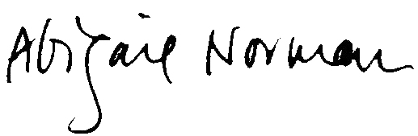
APPLICANT/EMPLOYEE INFORMATION (Please print)

__________________________________ _________________________________ _____________
Last Name First Name Middle Initial
_________________________________________ __________________________________________
Maiden Name or Alias (if applicable) Place of Birth
_______________________ __________–___________–__________
Date of Birth Social Security Number
___________________________________ ________________________________________________
Father’s Name: First Last
__________________________ ___________________________ _____________________________
Mother’s Name: First Maiden Last
______________________________________________________________________________________
Current Address
______________________________________________________________________________________
Former Address
_____________________________ _______________________________________________
Gender Race
_____________________________ _______________________________________________
Phone Email
____________________________
ID Theft Index PIN Number (if applicable). To be completed by those applicants that have been issued an Identity Theft Index PIN Number by the CHSB. Certified agencies are required to provide all applicants the opportunity to include this information to ensure the accuracy of the CORI request process. All CORI request forms that include this field are required to be submitted to CHSB via mail or fax: 617.660.4614.
Please attach photocopy of State Driver’s License, State ID, or other form of ID.

